Advance Computer Architecture Assignment-3

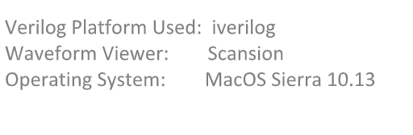

Submitted By-

Kanika Gera

2018H1030041G

Branch Prediction Buffer

**Architecture**

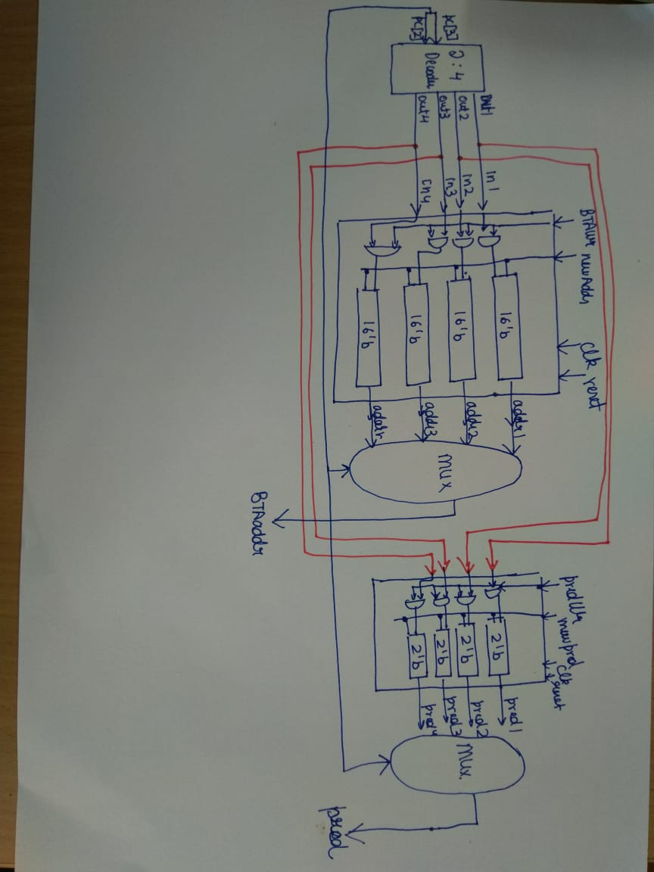

**Design Constraints:**

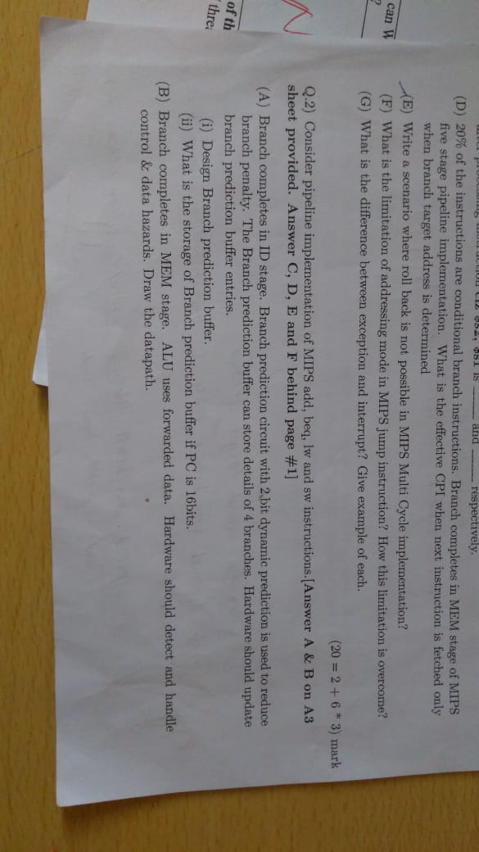

1. According to the given question , PC is considered of size 16 bits , hence BTA registers size = 16 bits.
2. Input to Decoder is 2 and 3 bits of PC. In Implementation of above hardware I have named variable **pc** which denotes PC[3:2] bits.

**Output as Waveforms**

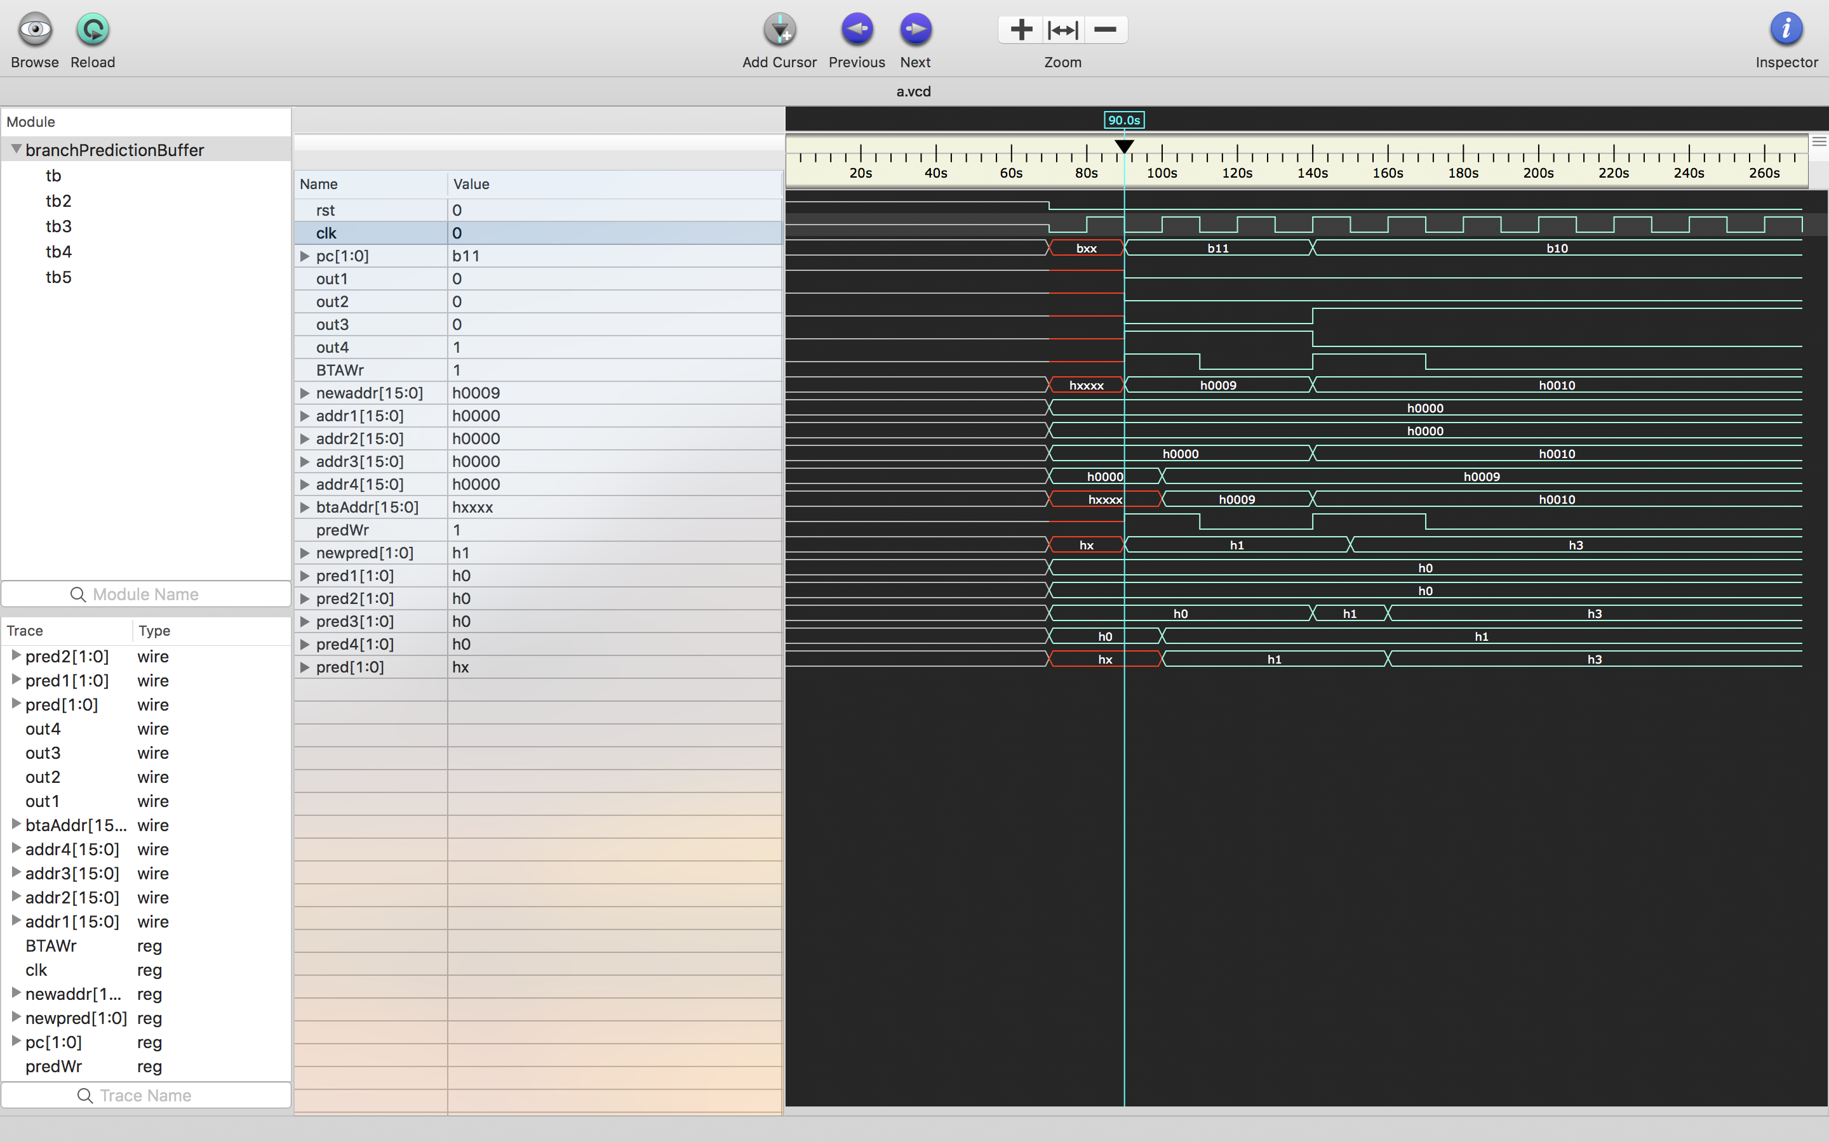

Here input to decoder1 represented by pc variable is set to 2’b11.

BTAWr control signal is set to 1.

newAddr i.e. new BTA to be written is set to 16’d9.

predWr is 1 and newpred is 2’b01.

In next positive edge of clock , addr4 is updated to 16’d9 and pred4 is updated to 2’b01.

corresponding prediction is read i.e pred= pred4

corresponding BTAaddr is read i.e. btaAddr = addr4.

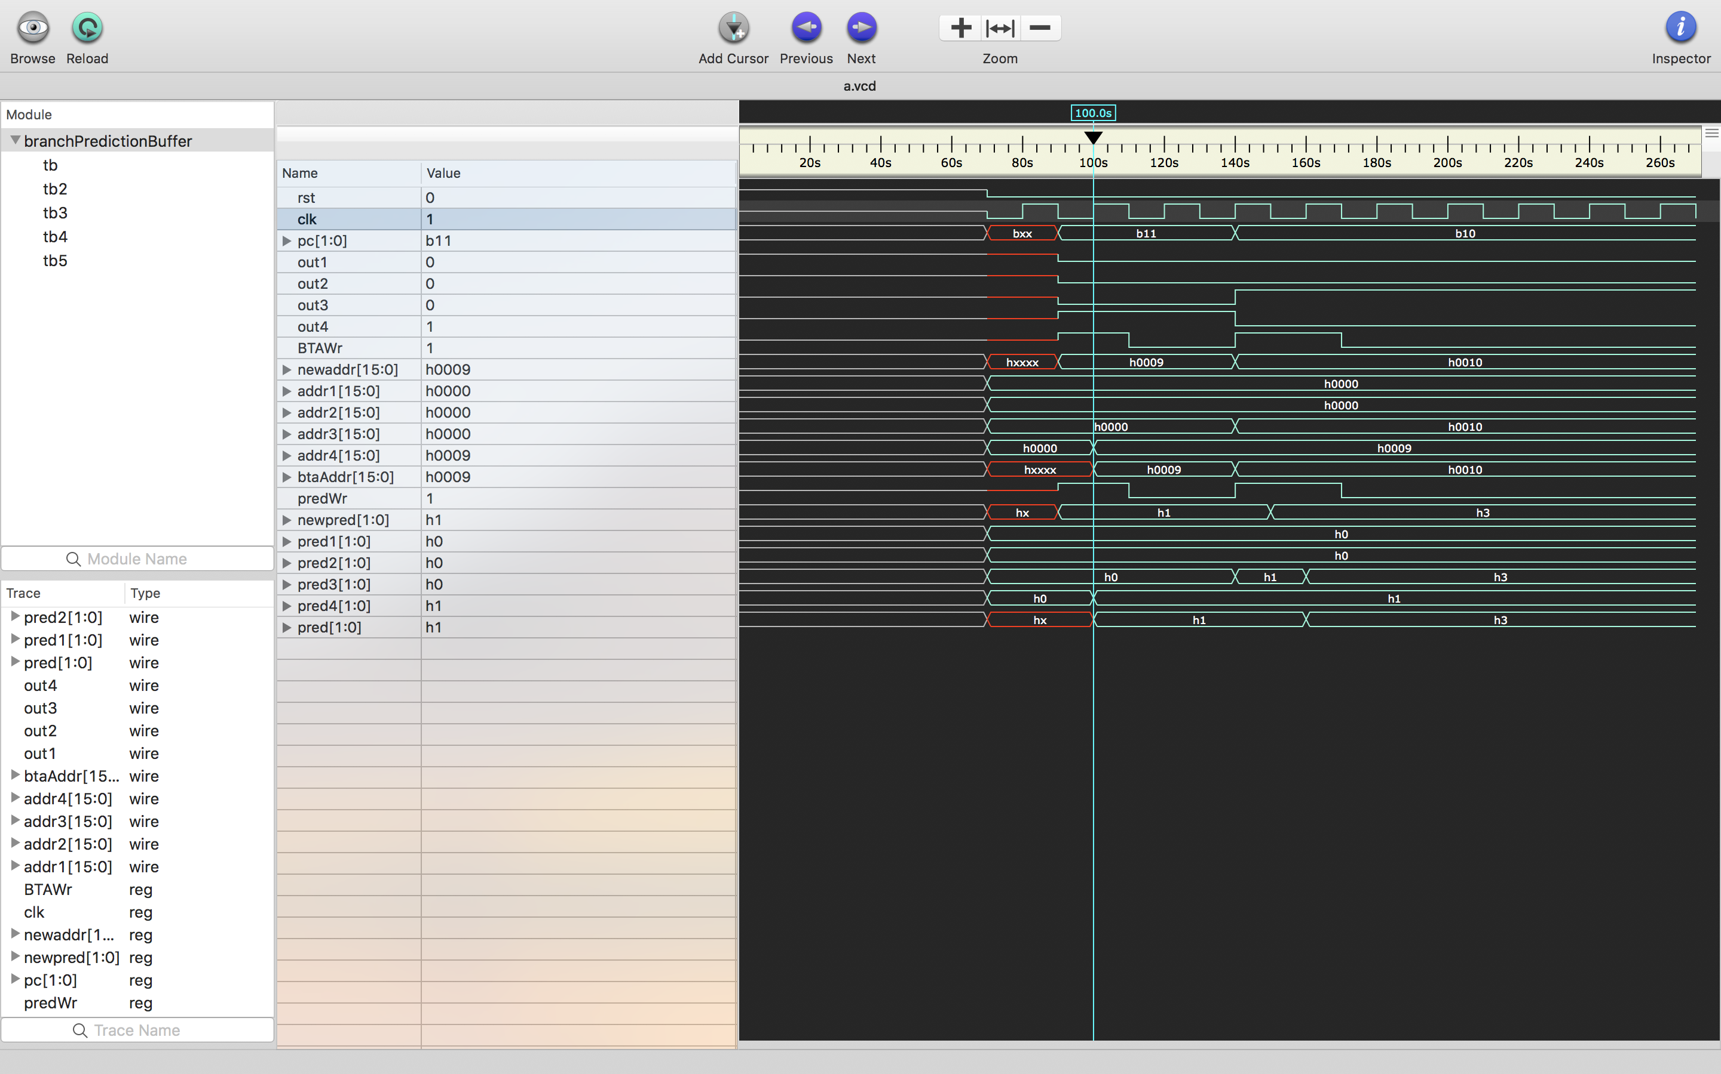

In the case when predWr is 0 and BTAWr is 0 and pc = 2’b11.

That is the same branch occurs again.

BTAaddr= addr4 and pred = pred4 is read

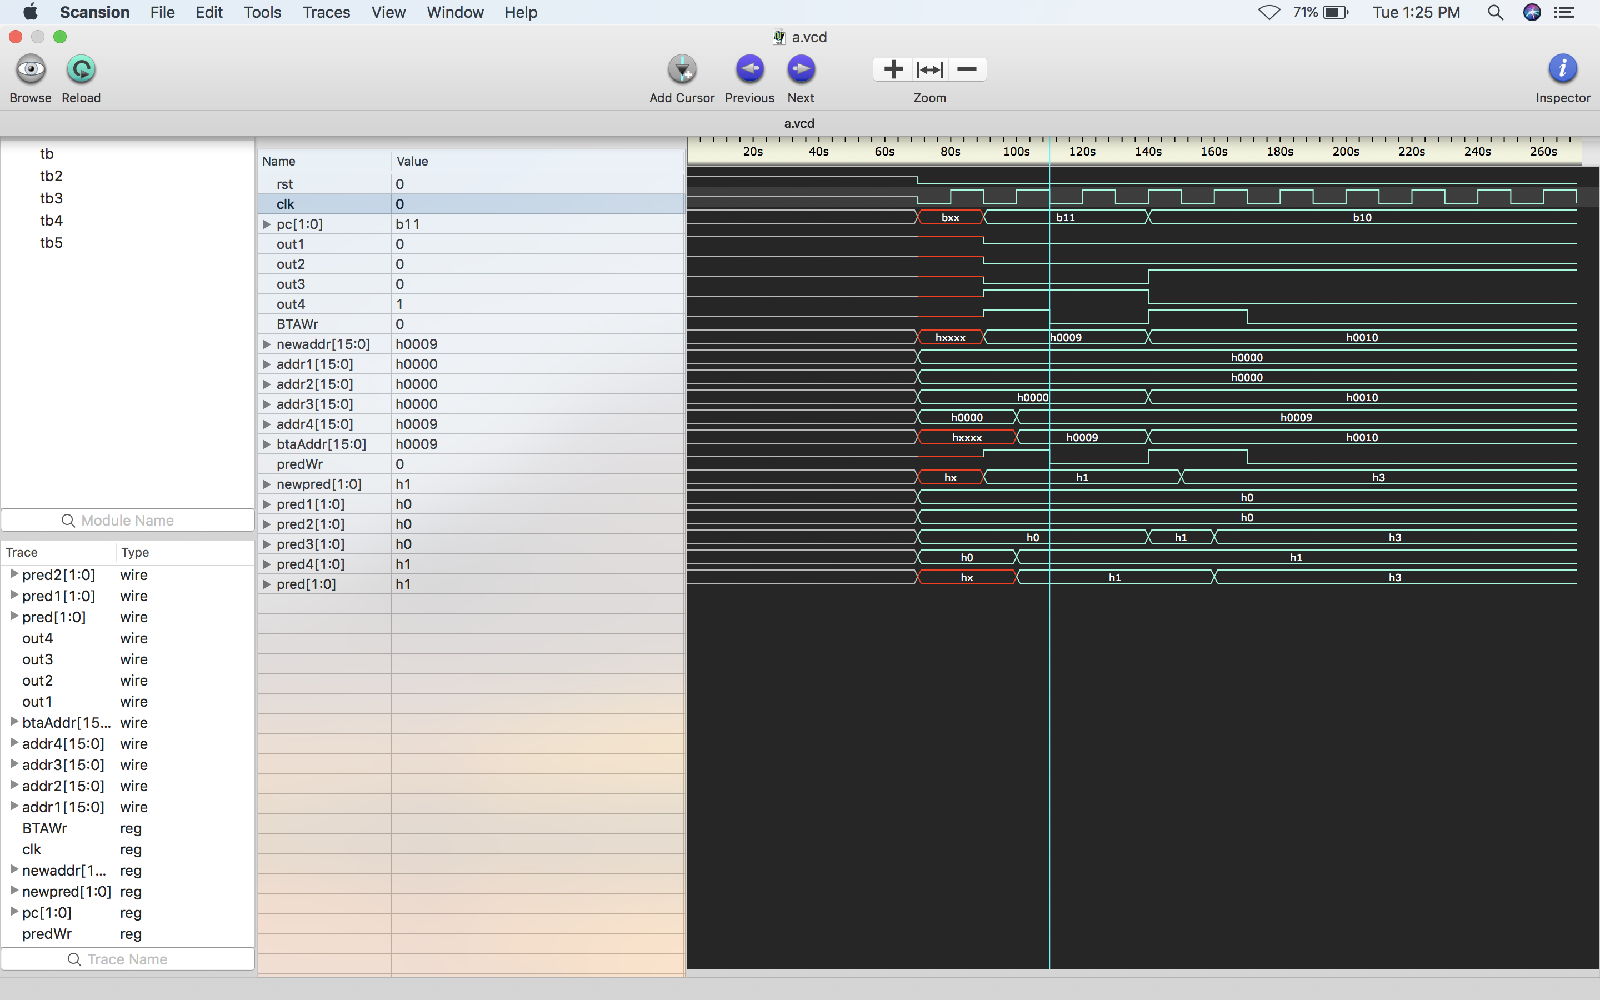

Same as above case , waveforms is shown for pc = 2’b10

newaddr = 15’d16.

newpred = 2’b01.

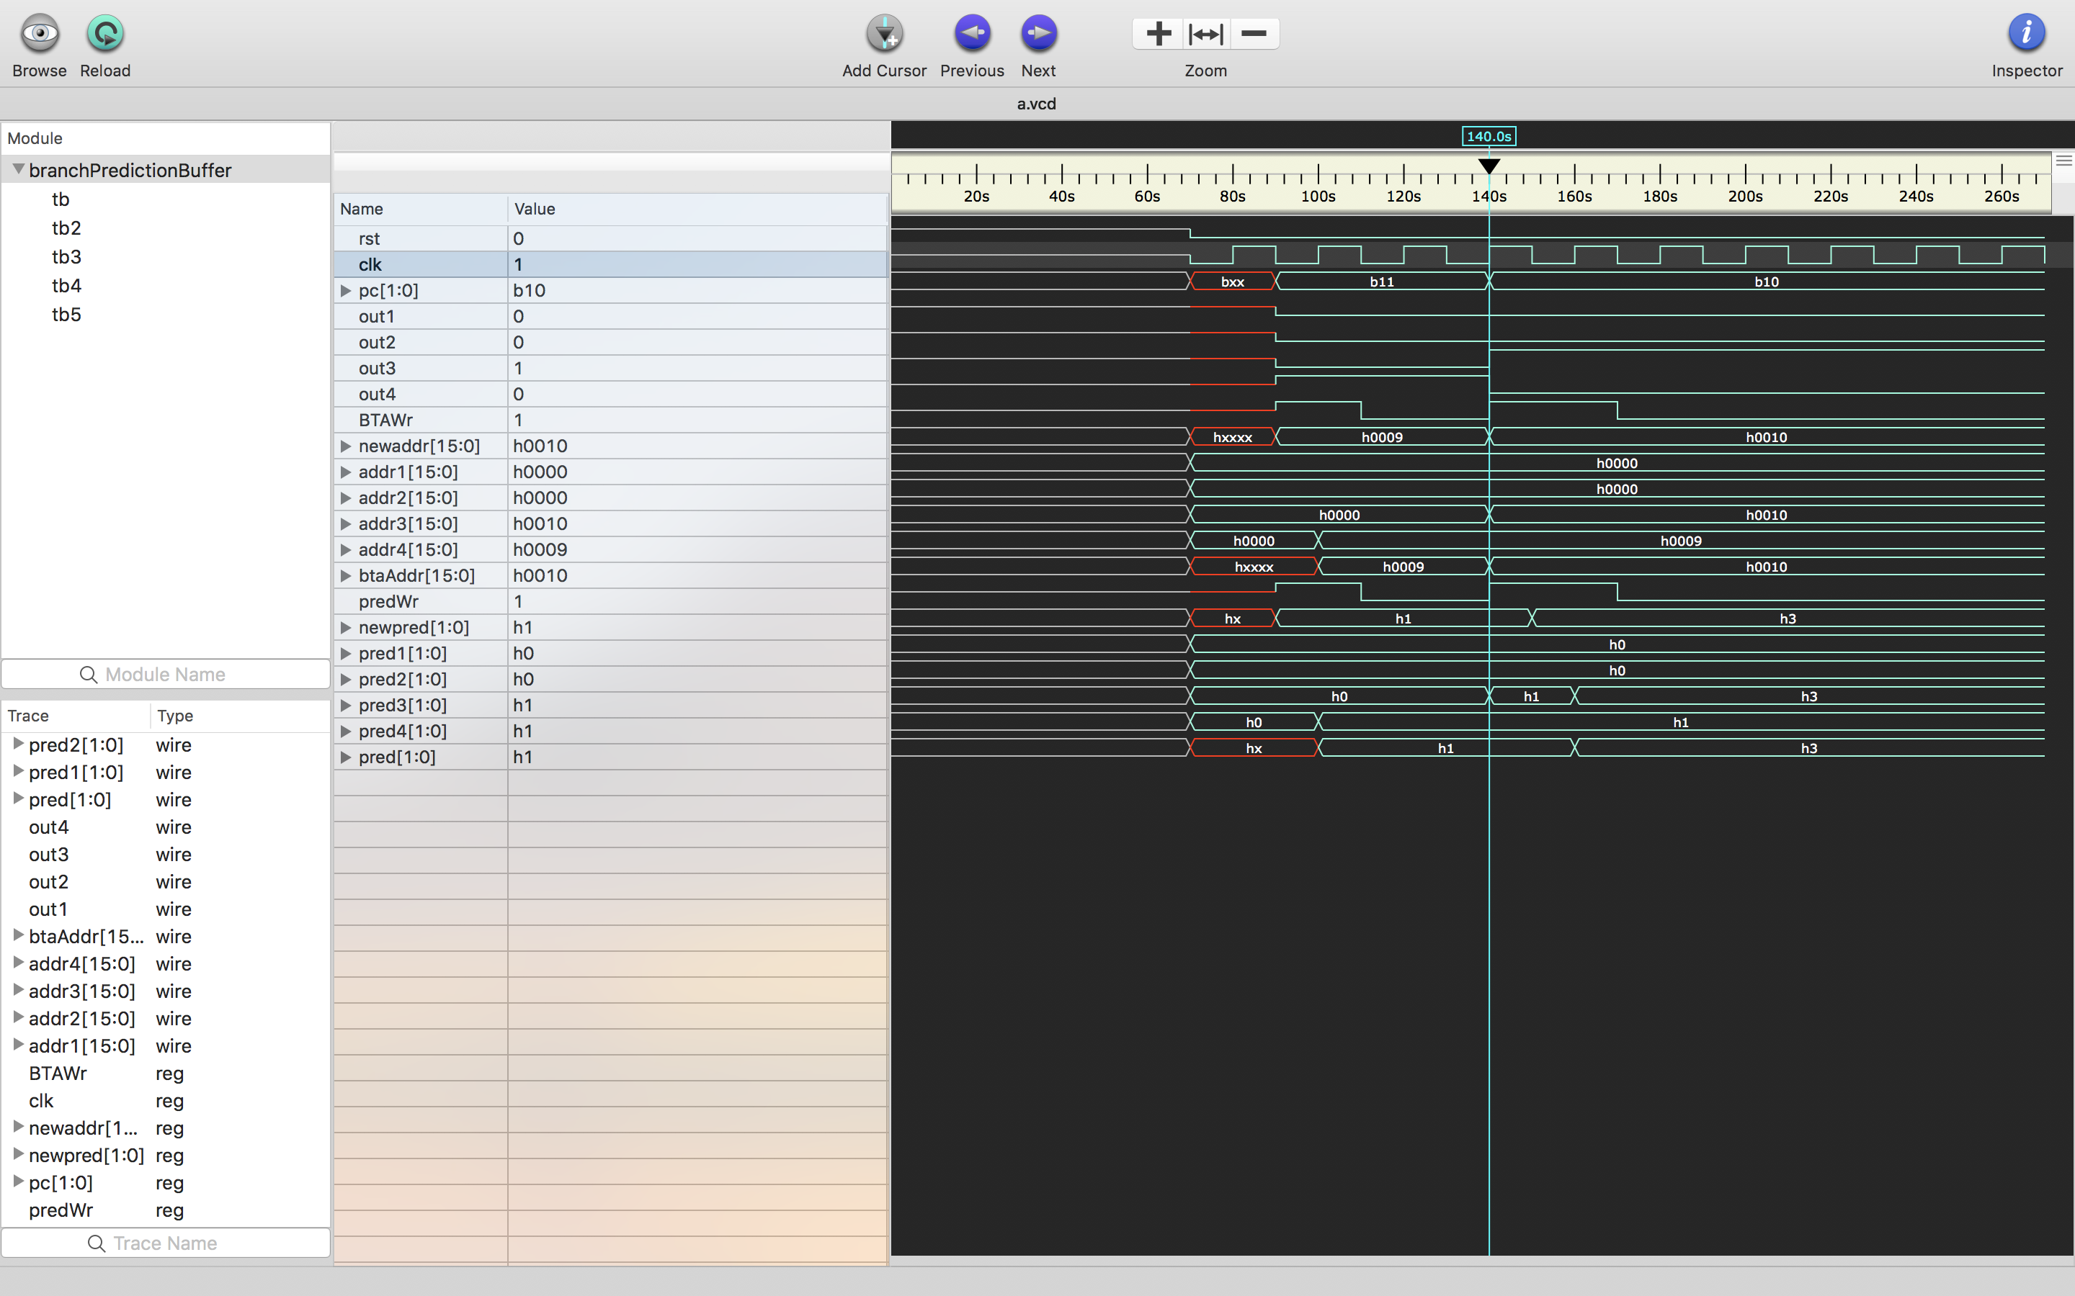

Same as above case , waveforms is shown for pc = 2’b10

newaddr = 15’d16.

newpred = 2’b11.

Situation occurs when prediction is wrong twice .

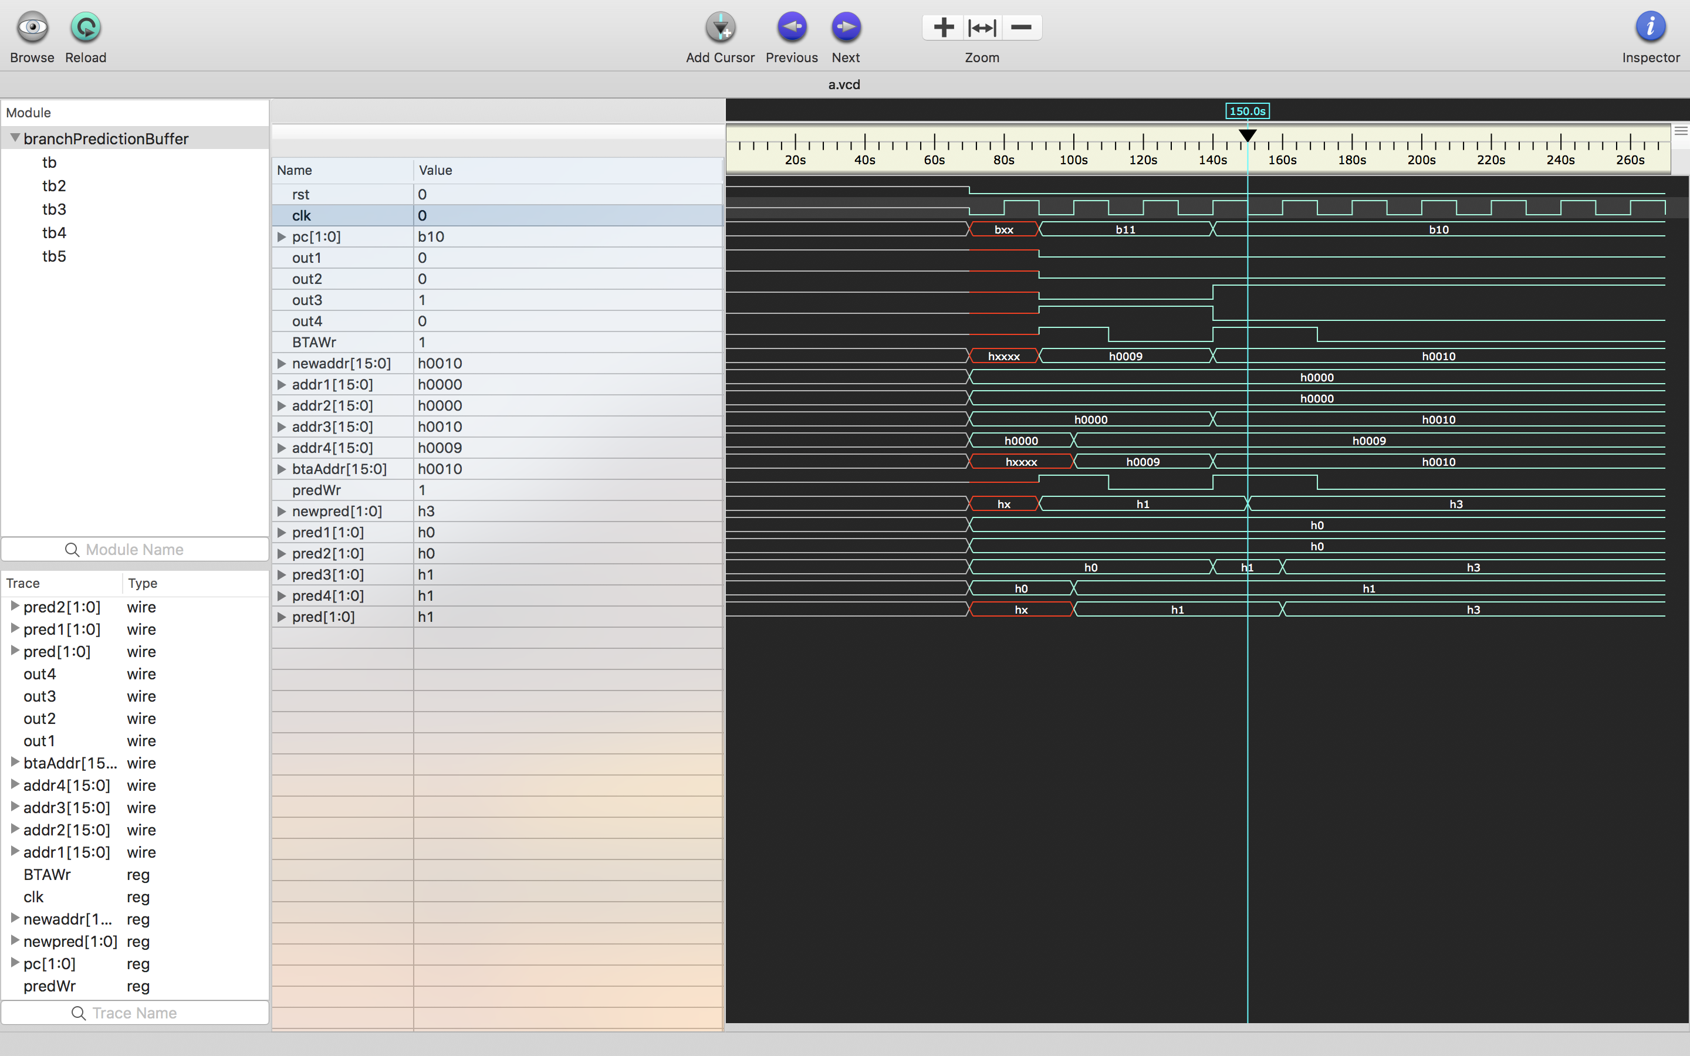

In next positive edge of clock , addr4 is updated to 16’d9 and pred4 is updated to 2’b01.

corresponding prediction is read i.e pred= pred3

corresponding BTAaddr is read i.e. btaAddr = addr3

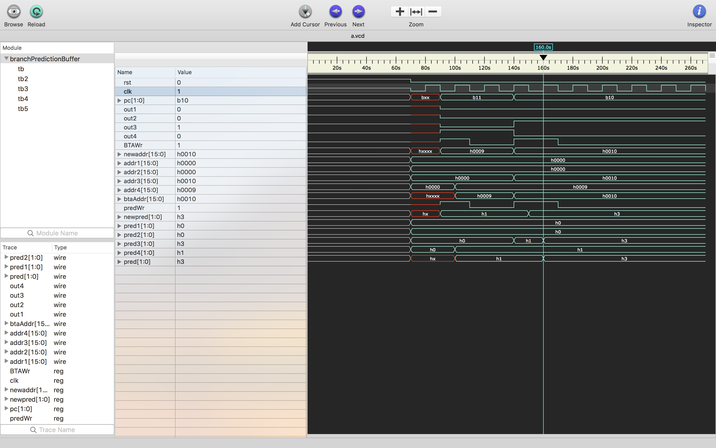

In the case when predWr is 0 and BTAWr is 0 and pc = 2’b10.

That is the same branch occurs again.

BTAaddr= addr3 and pred = pred3 is read.

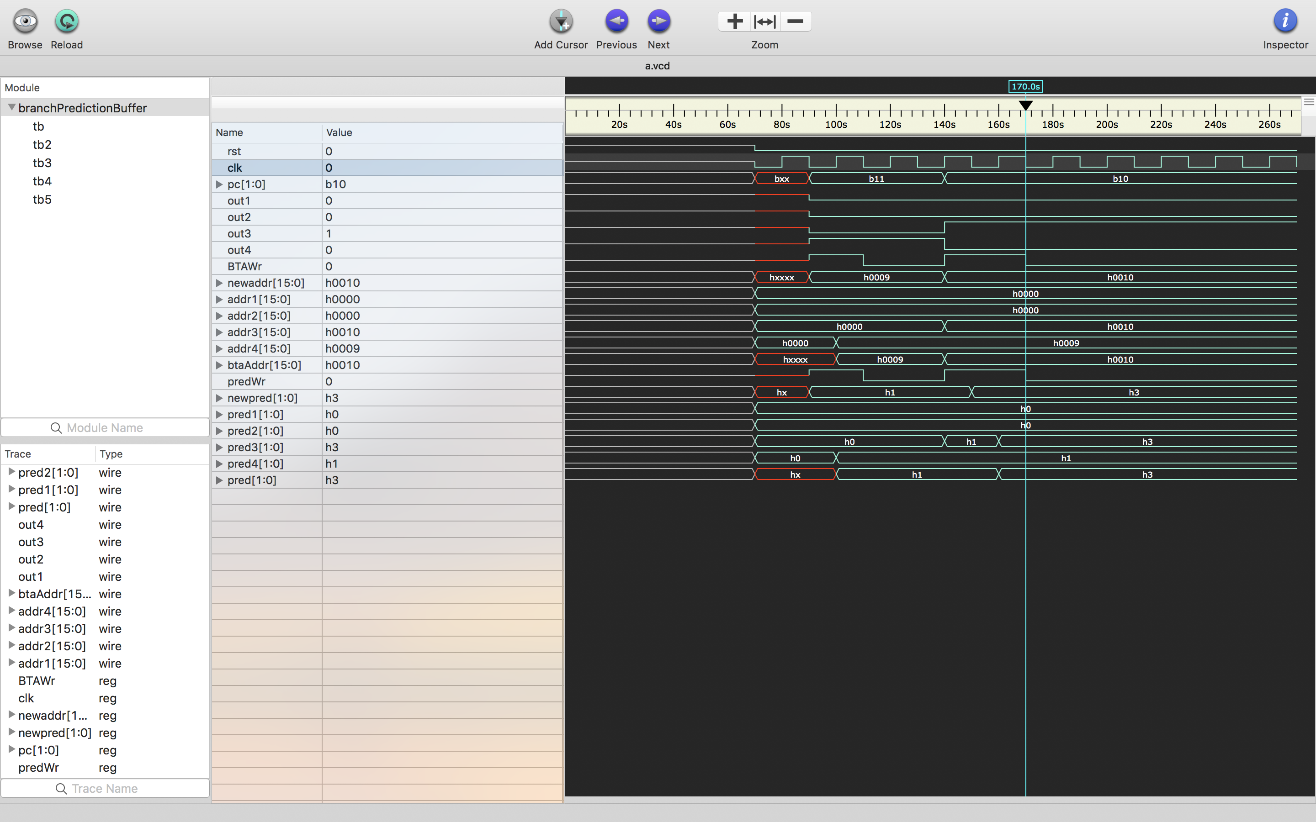

**Output on Console**

The summary of above can also be shown in the following output generated on console with $monitor command in Verilog.

